**E-mail: costas_mario@yahoo.com**

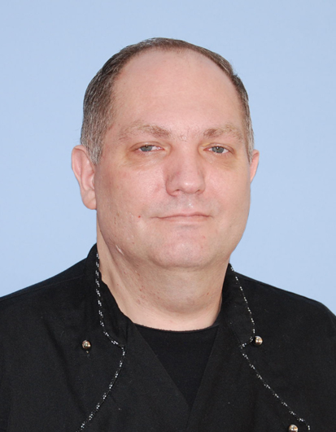

**Phone no: +40727060120**

**SkypeID:Costas.Marius.Laurentiu**

Current location-Romania

DOB:01/03/1969

Nationality : Romanian (EU Passport)

Full clean international driving license

Marital Status: Married

Languages: fluent English ,Greek

USA VISA///C1D///expiry date 27nov 2019

USA VISA///B1B2///expiry date 01 dec.2024

**QUALIFICATION:**

Diploma/Qualification of Barman/Waiters/Cook

Training courses for Chief Cook

Ships cook specialization

Hygiene course for catering personal

Security training for seafarers with designated security duties

Basic safety training

Maritime English

Familiarization safety training for ratings

Health and safety level 2

Food safety level 2

Food allergen

Working in a kitchen

**EMPLOYMENT HISTORY:**

**AUGUST -OCTOMBER 2017 Sous chef / Ms Nestroy-River Advice AG-Switzerland**

Duties & Responsibilities

Cooking and organized the sections in the galley

Oversees the quality and the hygiene of preparations

Responsible with stock supply and labels productions of food

**MAY 2017-JULY 2017 Training period sous chef /Bistrot Pierre-weston super Mare/UK**

**Dec 2016-March 2017 Chief cook at EDT offshore CYPRUS/Limmassol**

Duties & Responsabilities

Chief cook-cooking and care provision store on vessel

**Dec 2014-Jun 2016 Chief cook on vessel at Reederei Nord Germany**

**Company**

Duties & Responsibilities:

Chief cook-cooking and care provision store on vessel

**Nov 2013-Dec 2014 Chief cook on vessel at TMS BULKER LTD Greece**

**Company**

Duties & Responsibilities:

Chief cook-cooking and care provision store on vessel

**2011-2013 Nov Chief cook-in Constanta(Dimos Greek Tavern**

**Metropolis Greek Tavern and Hotel Rest.5 star VEGA)**

Duties & Responsibilities:

Organize for Greek restaurants in Constanta ,Romania

Sous chef job hotel Vega 5 star in Constanta ,Romania

**2007-2011 April Chief cook- different location and restaurants in**

**Greece(Kalamata,Rodos,Santorini,Athens)**

Duties & Responsibilities:

Chief cook-cooking and Organize the galley for good service

**2005-2007 Chief cook on vessel: Acergy -Norway company; Oskar**

**Wehr Reederei-Germany company**

Duties and Responsibilities:

Chief cook-cooking and care provision store on vessel

**1998-2005 Chief cook on vessel :ZIM container ltd.Israel**

Duties & Responsibilities:

Chief cook-cooking and care provision store on vessel

**1995-1998 Sous chef-Steak House restaurant-Romania**

Duties & Responsibilities:

Grilled food and Butchering

**1992-1995 Chef de parties-passenger ship-Greece**

Duties & Responsibilities:

Preparing cold cuts food and care for provision store on vessel

Copies of certifications are available upon request

**INTERESTS AND HOBBIES:**

**Swimming, skating, reading, travelling, cooking and study always for new gastronomy**

**SKILLS:**

**Cooking different food from international cuisine(germany,asian,mediterranean,mexican and spanish,french…)**

**Organize work in the galley and cooperate with chef steward for good service.**

**Cooking in front of customers**

**Fruits sculpture buffet**

**REFERENCES:**

**-Marius Onciu (Executive Chef at Subsea7-Norway)**

**Contact:0040744424175**

**-Constantin Gabriel(Chief engineer-on yacht”SeaDream”)**

**Contact:0040722848716**